**SEMESTER ROUNDUP**

**Fall 2019**

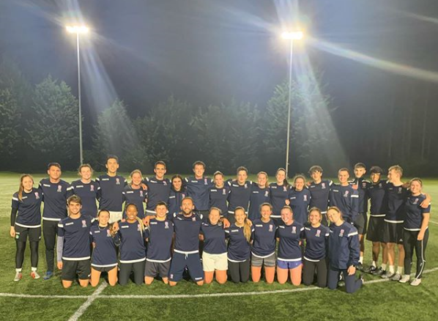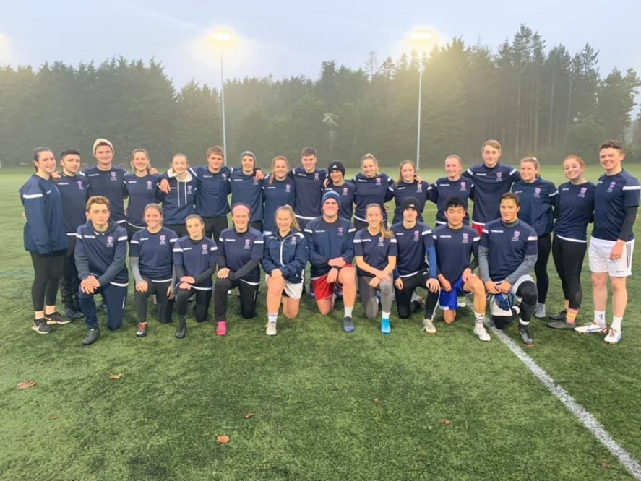

Thoughts and summaries of the season thus far provided by the Director of Football, the Club Presidents, and the Club Captains.

**Director of Football’s**

**Reflection on the Semester**

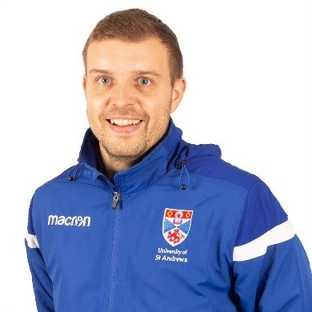

Firstly, may I take this opportunity of wishing you all happy new year. I hope that 2020 is a healthy and successful one for you.

With the festive period having now passed it offers myself, the coaching staff, the committee and players the opportunity of reflection on term 1 in which there was plenty to report on. Prior to everyone’s return for another successful pre season camp it should be noted the tremendous effort put in by the fundraising cyclists who raised a significant amount of money for Bloodwise with the cycle to Manchester challenge. The 3 days were hard, mentally and physically but what an experience it was to be apart of and getting the news that Charlie was given all clear whilst we were on a food stop at a rain soaked Tesco’s in Penicuik will live long in the memory. The togetherness shown from all participants and helpers during the challenge highlights one of the special features of this club and that should never be forgotten. We are all delighted for Charlie and the family that he is healthy again and eagerly look forward to the big man’s return to the university and getting back on the pitch later this month.

The feel good factor from the cycle event carried over into pre season camp and whilst the weather was not great in spells (to the point of the barbeque not going ahead this year) the same could not be said about the application the players showed throughout the camp. Once again another really good week and we were off and running (so to speak!)

Since then each of the teams within the programme has experienced different levels of results but at the time of writing this every team within the programme has plenty to play for which is what we want at this stage of the season. Once again, the women’s 1st team have set the bar high for everyone else with a perfect return of results so far. It promises to be an exciting semester for the group as they go in search of not only clinching a first 1A title (in my time here) and also possible play off promotion to Premier North League but also look for success in the British Trophy and Women’s SSS Scottish Cup. Whilst it may not have been the semester the 2nd & 3rd team would have liked both still have plenty to play for this term in the quest to finish as high as possible in their respective leagues. Both squads have quality and with a few changes here and there will be ready to go come the restart and I am very confident in what they will be able to in the games ahead. I would like to take this opportunity of thanking Allyson and Rebecca for all their efforts so far with the development squad that continues to offer social recreational football on a weekly basis.

**Director of Football’s**

**Reflection on the Semester**

For the guys it reads a similar story with a mixed report to tell of. Whilst the results have seen the 1st team not in the position they would want to be in from a league perspective the cups offer some incentive of doing well in with the possibility of another battle against our old friends from Stirling in the QPS. For the 2nd team the agenda is simple and to win every game they face to stand a chance of promotion. After a good start there were a few bumps in the road but with plenty to play for in the league and with the possibility of 1s v 2s cup semi final on the cards the stakes are high going into the business end of the season. For the 3s it has been a frustrating term so far with a lack of games being the root of this problem. That being said, there will be plenty this term to look forward to as the group aims to get as many points as they can. The 4th team have done exceptionally well so far and going into term 2 are right in the mix for promotion so I look forward to seeing James and Ali continuing the work they have started and hope they can achieve their goals in the coming weeks. After a slow start in the league the 5th team are now up and running and found form towards the end of the term which led them to progression to the plate quarter final as well as picking up points in the league to start their climb up the table. The 6th team have been really good and despite a few results not going their way towards the end of the term have already broken last year’s total with games still to play. The challenge for them is to set their highest ever BUCS points tally which is well within reach. From a Saturday perspective we are in a really good place with the amateur team and at the time of writing sit 2nd in the league table with promotion being top of the agenda. It won’t be easy with the number of games to play but to win a league title you need to work hard for it and so I am looking forward to embracing the challenge this offers as well as good run in the league and Fife Cup. The development squad have had a very good first term led very well by Matthew, Sverrir and Euan and although experienced defeat in their first game at the end of the term against St Andrews Colts Amateurs and gave a really good account of themselves. Like all the teams I look forward to seeing them continue to progress this term.

Away from the pitch we have made a very positive move with the introduction of training kit which looks great and it was fantastic to be able to host our first ever Thanksgiving event that I look forward to making it an annual event in the club calendar.

It promises to be an exciting term as we look forward to Ball in April (hopefully we will be able to confirm a venue, date and other arrangements very soon) and the return of our tremendous alumni from all over the world. In addition to this the volunteer work we have begun will once again be important as we go in hunt of internal awards such as the Athletic Union club of the Year in addition to retaining Volunteer Club of the Year.

I hope that you are looking forward to term 2 given how much there is to play for on and off the pitch. Please stick together and embrace everything we face as a club. We have made some positive steps forward as we strive to make this the best club we can whilst in doing so reflecting the values we hold. There has been challenges but with your continued support, hard work and application can once again make it a season to remember! Enjoy the remainder of your break and I look forward to seeing you again very soon.

Kind regards

**Stuart Milne**

**Director of Football**

**Men’s President Semester Summary**

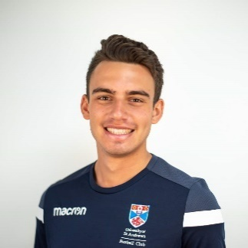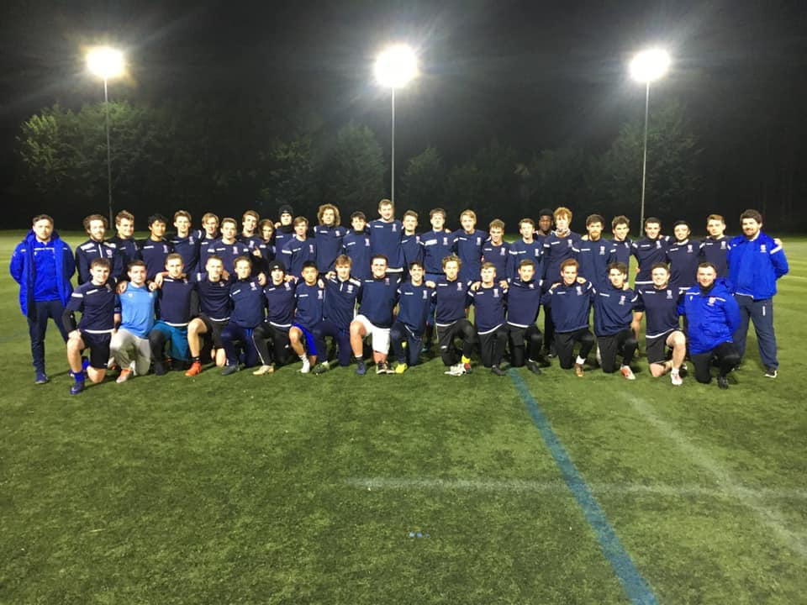

This first semester has seen success for the club both on and off the pitch, with all the teams producing some very positive performances and results. We have also seen incredible progress of our development squad, thanks greatly to three student coaches, who are playing more competitive games and improving both as individuals and a team. I believe this is representative of the One Club attitude we are still developing, with more and more players coming down to watch and support other teams when possible. This has also spilled over to a greater integration with the Women’s side of the club, which we all believe to be a positive change.

There have been individual standout performances from across the program, with this reflecting the professionalism and high standards of every team. Furthermore, the addition of our two male scholars has proven to be a significant benefit in BUCS and Fife league action with them playing a considerable role in victories in both competitions. Finally, we have introduced club training kit that I believe has further pushed up standards in our pursuit of excellence.

**Sami Azam-Ali**

**Men’s President**

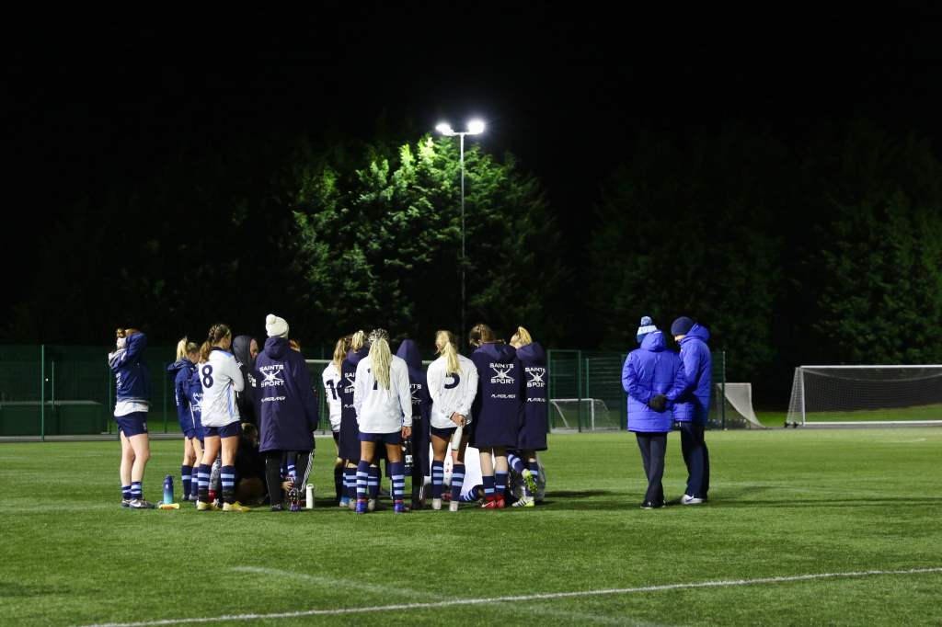

**Women’s President Semester Summary**

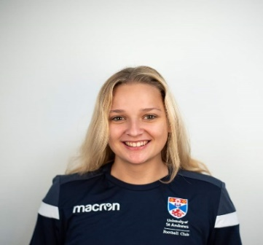

The women's side has had a fantastic first semester. We have had very productive seasons across all three teams, and excellent progress and attendance from our Development Squad. We started the semester with a wonderful preseason with great new additions from freshers and new members as well as our new postgrads, all of which have made quite the impact! Starting with league and cup competitions, the Women's 3s have had promising results and an incredible team dynamic, the Women's 2s have had a transformative and progressive season, which will contribute to their success in the second semester. The Women's 1s have exceeded expectations in their undefeated season in both league and cup. Off the pitch, we have continued our involvement with the St Andrews and East Neuk Community football girls, someone from each team helping out every Saturday morning. In November, we hosted several football events, one in which we involved the community girls, having a q&a with them before a first-team match, and having them as ball girls during the game. We also had our first organized family week, which was very successful! Further, the one club attitude which we continuously strive for has continued with increased social integration with the men's side.

We believe the groundwork and effort put-in in our first semester will significantly aid us in future success in the upcoming semester!

**Katie Nelson**

**Women’s President**

**Men’s 1st XI Semester Review**

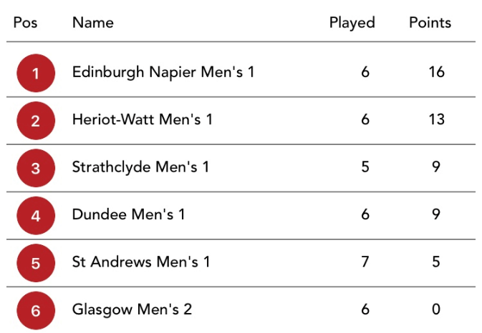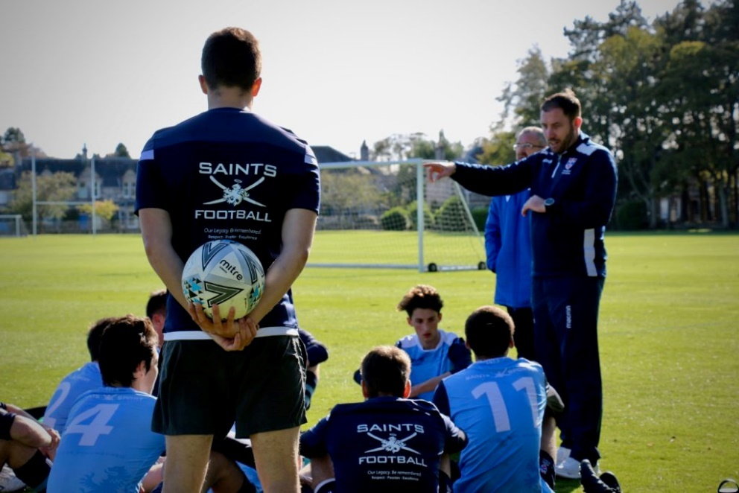

**CAPTAIN’S SUMMARY:**

The Men’s 1st team experienced a rather lacklustre semester 1 this year. An impressive 4-1 varsity  win over Dundee created a feeling of great optimism. However, injuries and individual mistakes have meant that we have not been able to live up to expectations. This being said, recent cup performances have meant that there is much to look forward to in 2020. Flynn Gray’s hat-trick helped the 1s record a 4-0 QPS victory against Strathclyde in what was undoubtedly the finest team performance I have witnessed in my time in the Club. As such, we have been awarded a glamour tie against the winner of Edinburgh College (the current holders) vs Stirling 1s. Similarly, we have a Conference Cup Quarter Final to look ahead to after beating Strathclyde 2s despite being down to ten men last semester.

Finally, it has been a real pleasure to welcome the freshers to the 1st Team group; each of them has a bright future within the Club and University. The omnipresent Stuart Milne Player Pathway continues to highlight the talent throughout the Club and we welcomed our first batch of Postgraduate Scholars. All of this points towards the inevitable success of the Men’s 1s, not just this semester, but beyond that.

Findlay Tough

Men’s 1st Team Captain

**END OF SEMESTER STATS**

**LEAGUE POSITION: 5th**



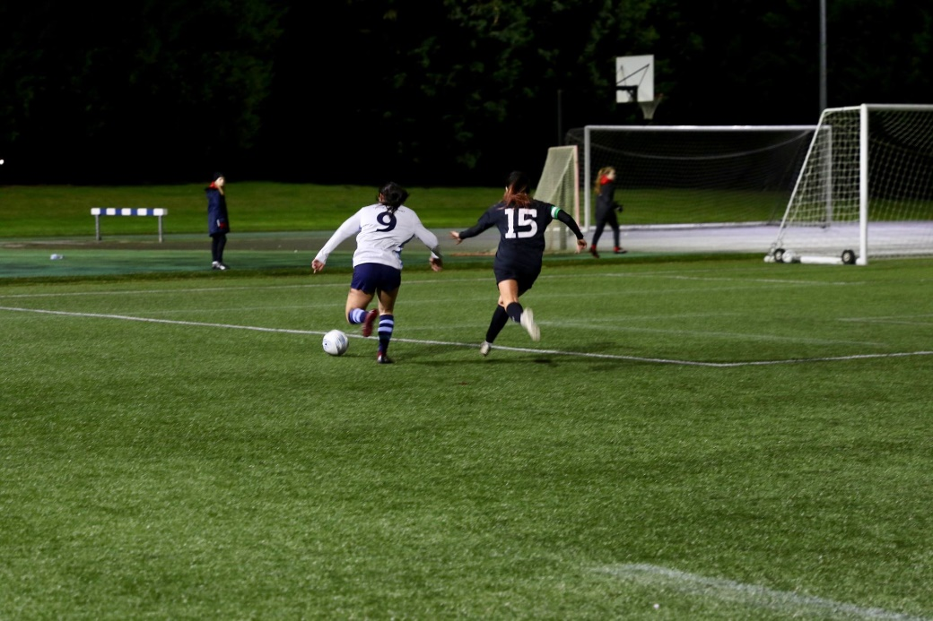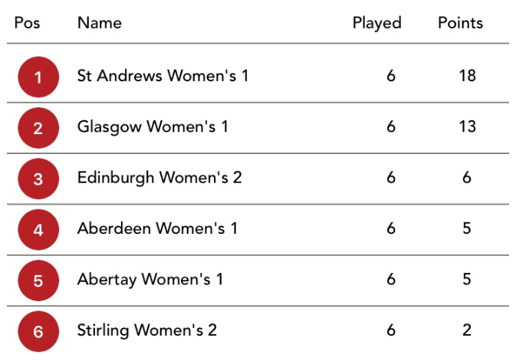

**END OF SEMESTER STATS**

**LEAGUE POSITION: 1st**

**SEMESTER SUMMARY:**

The Women’s First Team concluded our undefeated first semester with several accomplishments. Currently sitting top of our league, and still in two cup tournaments, we have surpassed our own expectations. With goals coming from across the team, frequent hat tricks, advanced set pieces, and consistent clean sheets, we have set ourselves high standards.

Our win in the first round of the British Cup against Leeds’ 1st team was the perfect culmination of our hard work. With winter preseason starting, the women’s first team will be the team to watch (if you ask me).

Natalie Kelley

Women’s 1st Team Captain

**Men’s 2nd XI Semester Review**

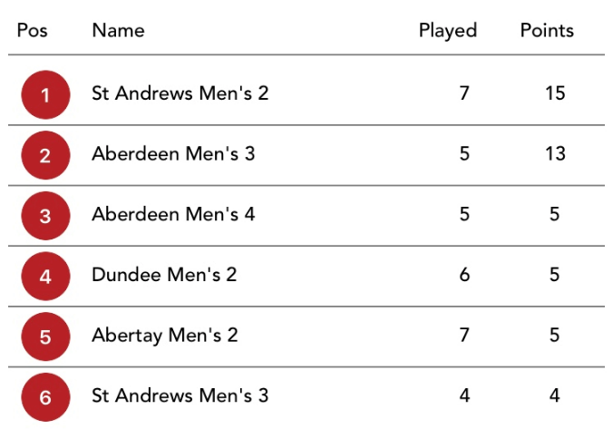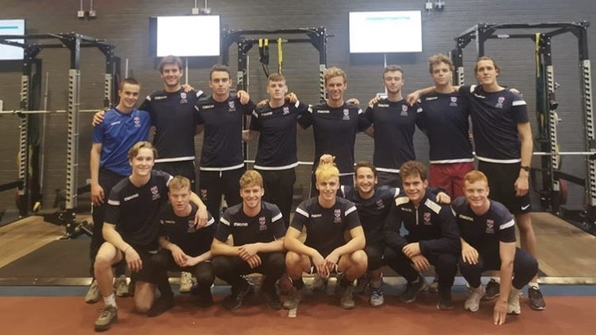

**CAPTAIN’S SUMMARY:**

The 2s got the season off to a flyer with a 5-1 win in varsity followed by a 5-0 win in the first league game of the season. The boys continued in the same vein with some great individual and team performances across the semester with a special mention going to our freshers: Adam, Cammy, Charlie and Alex, who all hit the ground running  and have been fantastic additions to our squad. Despite a couple of poor performances the 2s are shaping up to have a successful season with a cup quarter final and title race to look forward to after the break and I want to congratulate the players on their efforts and commitment thus far and hopefully we can carry that into next semester.

Daniel Cohen

Men’s 2nd Team Captain

**END OF SEMESTER STATS**

**LEAGUE POSITION: 1st**



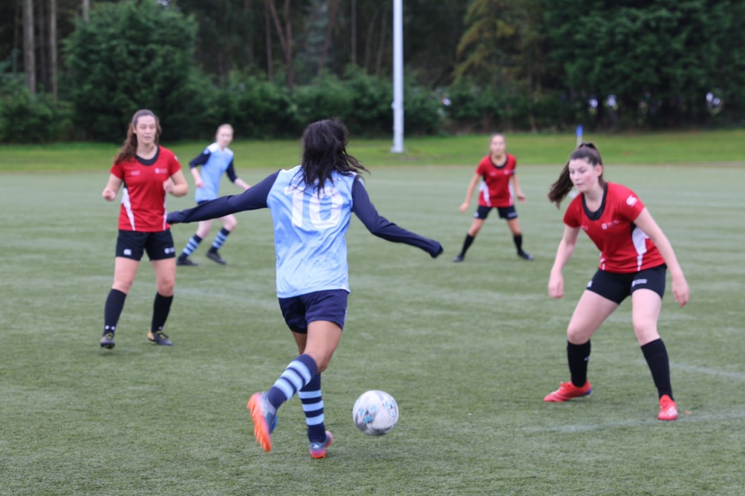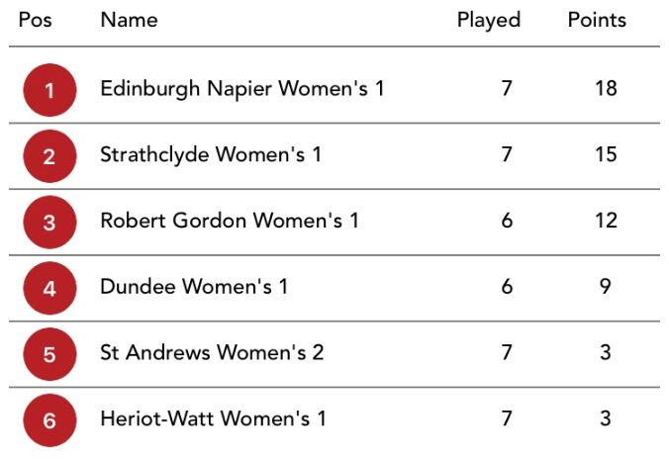

**END OF SEMESTER STATS**

**LEAGUE POSITION: 5th**

**SEMESTER SUMMARY:**

It has been a challenging semester for the women’s 2s as we made our tier 2 debut as the only second team in the league. I am so proud of the team’s determination and grit this season, and our level of play has grown in leaps and bounds since we started playing together!

This was apparent in our heart-breaking loss through penalties to the Napier Women’s 1s, who are sitting top of the table. We are lucky to have such a supportive squad of returning players and star freshies to lead on and off the field. We are excited to finish the season strong this semester and secure our place in the league. Thank you to Claire and Aaron!

Page Light

Women’s 2nd Team Captain

**Men’s 3rd XI Semester Review**

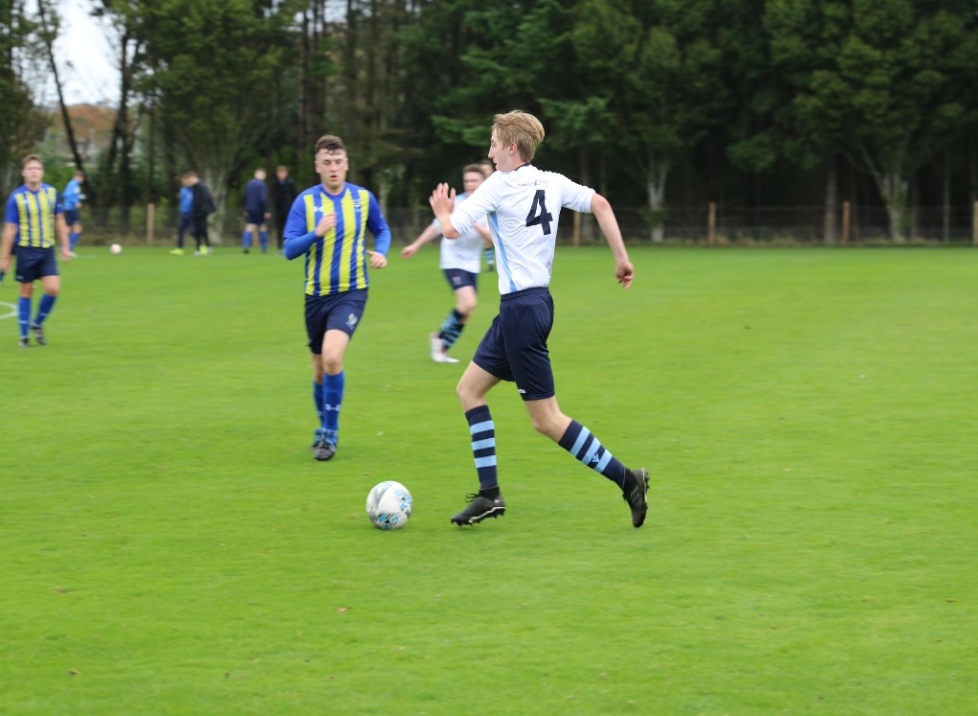

**SEMESTER SUMMARY:**

The Men’s 3rd team has had a relatively successful semester this fall and winter, with a record of 2 wins, 3 losses, and a draw, the highlight being a 5-1 thrashing of Dundee 3s in the Varsity Match. With 7 freshers joining the squad along with 10 returning players, the amount of new talent was substantial, and has been extremely key to some of team’s successes. While our fixture schedule has only permitted us to play 4 league games, it means we have 5 league games to play this semester, with 2 games in hand over a number of teams in our league. The Men’s 3rd team are looking forward to the challenge in 2020 and wish everyone at the Football Club, current players and alumni, every success this year.

Nicholas Lewis

Men’s 3rd Team Captain

**END OF SEMESTER STATS**

**LEAGUE POSITION: 6th**



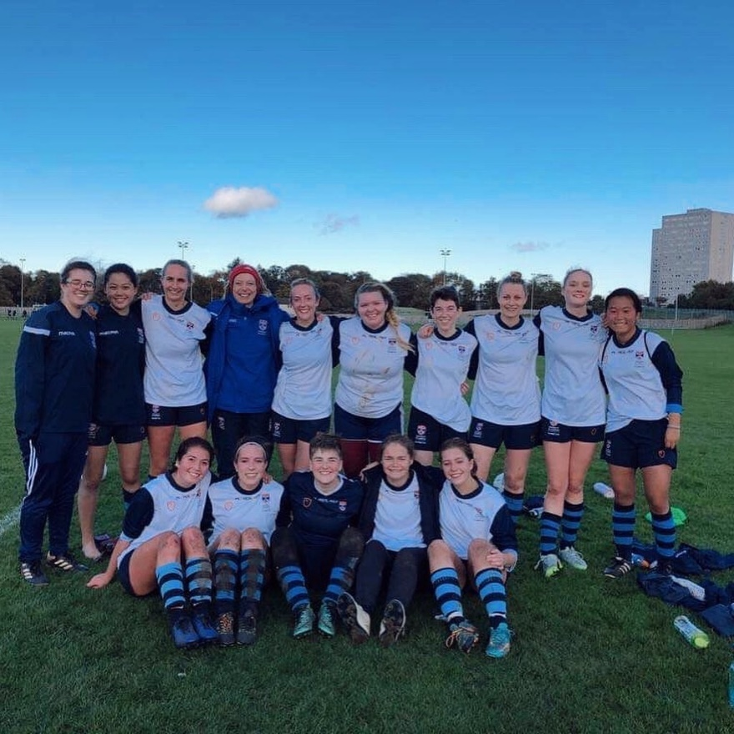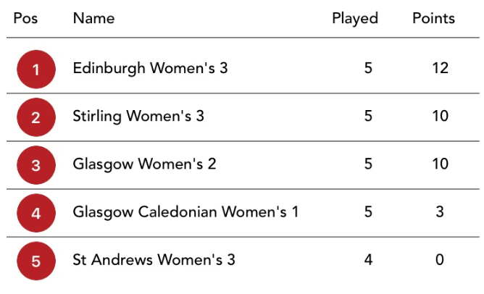

**END OF SEMESTER STATS**

**LEAGUE POSITION: 5th**

**SEMESTER SUMMARY:**

Overall the 3s last semester has created a cohesive and positive team atmosphere - our performance and development have been constantly improving.

The spirit and drive within the 3s has stayed at a high level. With the fixtures coming up this semester the 3s are looking to work harder and improve their league standing.

With five games left in their Scottish 3A season, the 3s will have some good opportunities to build on their performances of last semester and to finish the season in an improved standing.

Lauren Archer

Women’s 3rd Team Captain

**Men’s 4th XI Semester Review**

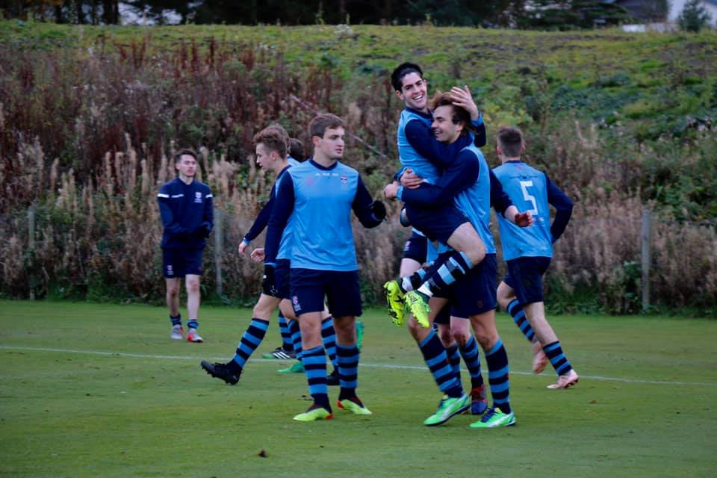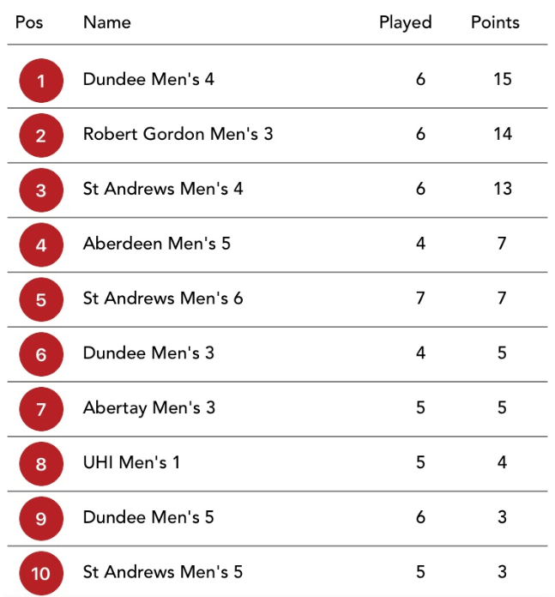

**SEMESTER SUMMARY:**  
Last semester for the Quatros was nothing short of brilliant. From the start of the semester, all of the boys have worked hard in training and put the effort in, and this has clearly been shown in our results.

From the loss in the varsity to now, being two points off the top, reflects our hard work. Every team member deserves praise for this. Along with our coach, Fitz, and his genius set piece routines and commitment to the team. I cannot say it enough; the Quatros have been brilliant.

I would like to include a highlight of last semester, this of course being our 10 (yes 10)-1 win against Dundee. This sums up our season so far, and myself and the boys cannot wait for semester two to start.

Alistair Robinson

Men’s 4th Team Captain

MENS 4th XI CAPTAIN

**END OF SEMESTER STATS**

**LEAGUE POSITION: 3rd**

**Men’s 5th XI Semester Review**

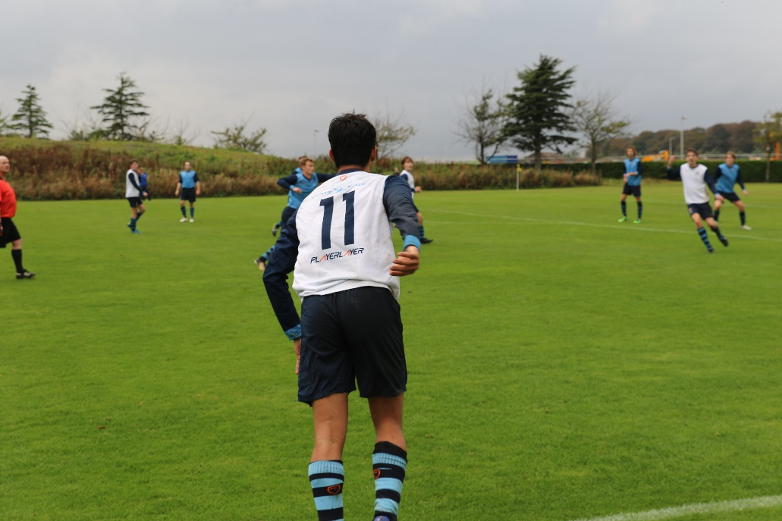

**SEMESTER SUMMARY:**

When looking at the results of the team, it’s fair to say the 5s have had a first semester of two halves. Whilst we begun the season with what can be described as a somewhat rough start to the season, the season has developed into a series of cup victories and strong signs of us reversing our initial form. This can be seen with the strong home cup victory against Heriot Watt. Whilst currently sitting 10th, this semester holds a lot of promise for the Men’s 5s, and hopefully it’ll be onwards and upwards for the remainder of the season.

Alex Watt

Men’s 5th Team Captain

**END OF SEMESTER STATS**

**LEAGUE POSITION: 10th**

**Men’s 6th XI Semester Review**

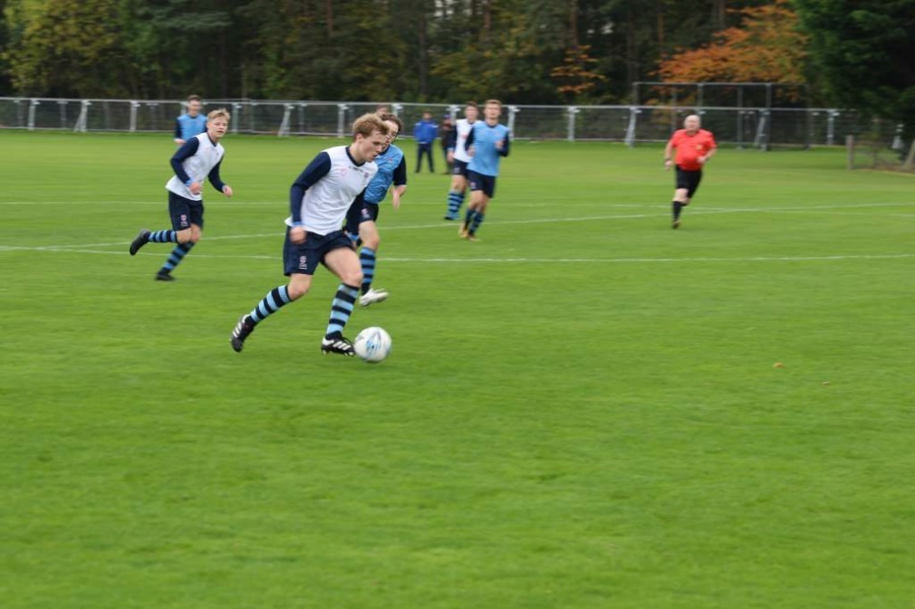

**END OF SEMESTER STATS**

**LEAGUE POSITION: 7th**

**SEMESTER SUMMARY:**

We’ve had an exceptional first semester, currently sitting 5th in the league and arguably feel hard done by not having picked up more points. The lads have showed exceptional attitude not only in games but also in training and I think this shows with some of our performances thus far. If we can win our last two games of the season we will equal the record points in a season for the sixes and we definitely believe we’re more than capable of achieving this. The highlight of the semester was beating top of the league Dundee 4s on their own turf. I hope we can replicate this performance again this semester.

Alex Phillips

Men’s 6th Team Captain

**Men’s Development Squad Semester Review**

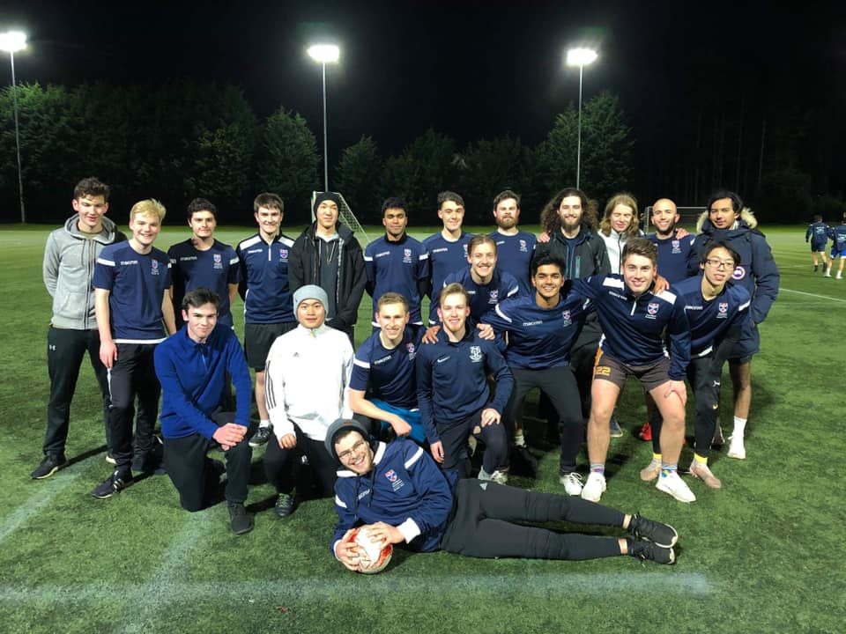

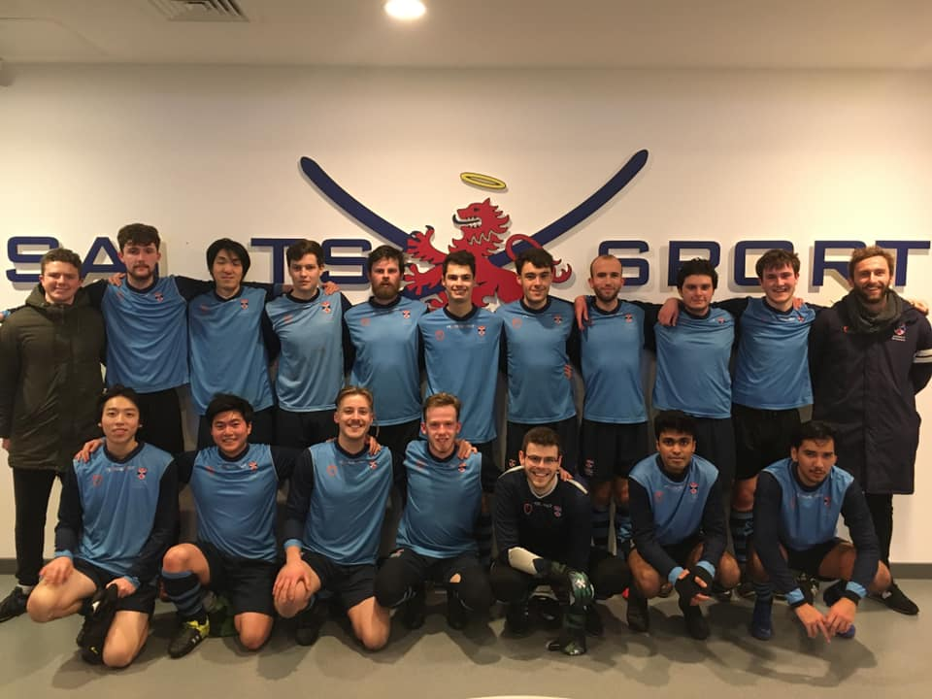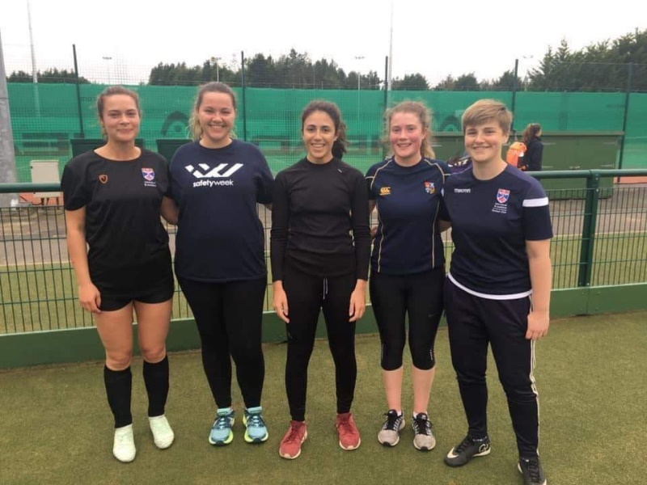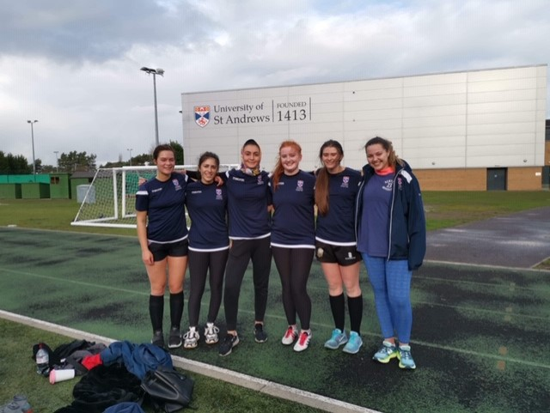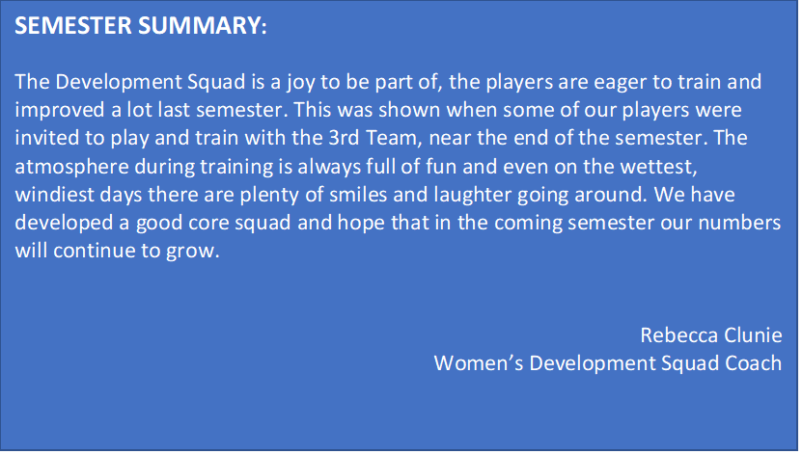

**SEMESTER SUMMARY:**

Going back to the start of the semester 1 the boys have come on leaps and bounds, their attitude and commitment to the training has been outstanding.

This commitment has allowed the boys to progress, enabling us to do complex drills and shape work, and the opportunity to play friendlies against local amateur teams and our own BUCS outfits. The first friendly against our 6s allowed the players the chance to show why they should be moved up. It ended up with 3 players, who started out in the Development Team, assisting and scoring against us in this match. Clearly showing the Development Team provides a platform for players to progress in the Club. The second friendly, against a local side, saw us try players in new positions and gave us much needed game experience and fitness. Unfortunately losing the game in a ten-minute spell, the boys battled hard and were rewarded with an outstanding goal.

For this semester we hope to continue to integrate with the competitive outfits and the rest of the club. Developments such as GK training being taken by the 2’s keeper will be continued and hopefully get more players from other teams involved. We look forward to this semester and hope to have more game time, more players getting moved into competitive teams and constant improvements each week.

Matthew Irvine

Men’s Development Squad Coach

**Men’s Amateur Team Semester Review**

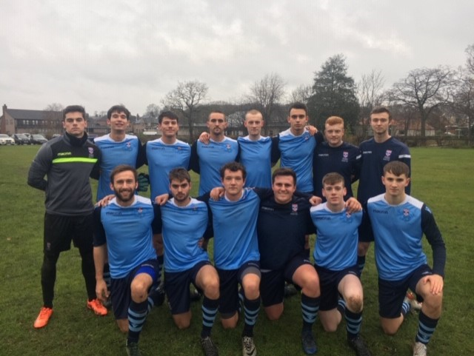

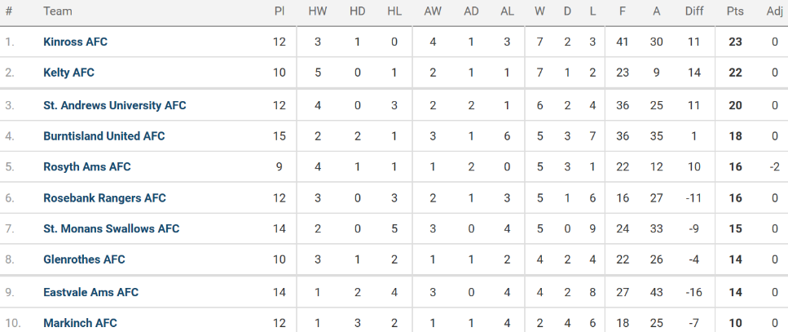

**END OF SEMESTER TABLE**

**SEMESTER SUMMARY:**

The Men’s Amateur side began this season in the Kingdom of Fife Championship after promotion from Division 1 last year. Slow would be the word to describe the opening stages of the season. This is best seen with a disappointing 5-5 draw away to Burntisland, despite the Amateur side holding a healthy lead for much of the match. Form since the start of the season has become more consistent though, this has led to the side picking up points and climbing up the Championship table. Strong team performances have been seen throughout the mid to later stages of the semester, notably a 5-1 victory against Kinross and a 4-2 away win at St Monan’s in the final game of the Semester.

The Amateur team currently sit 3rd in the League with a game in hand, this is a strong foundation to build on and to continue to push for promotion this semester. The side also remain in the Fife Cup, meaning a Semester 2 cup run is very much on the cards.

Dan Ross

Men’s Amateur Team Player